Exp008
Working with AngularJS Directives
Code
<!DOCTYPE html>
<html lang="en" ng-app="commentApp">
<head>
<meta charset="UTF-8">
<meta name="viewport" content="width=device-width, initial-scale=1.0">
<title>Comment Box</title>
<script src="https://ajax.googleapis.com/ajax/libs/angularjs/1.8.2/angular.min.js"></script>

<style>
body {
font-family: Arial, sans-serif;
margin: 30px;
}

textarea {
width: 100%;
max-width: 550px;
height: 100px;
padding: 10px;
}

button {
margin-top: 10px;
padding: 8px 15px;
cursor: pointer;
}

li {
margin: 12px 0;
}

.remove {
color: red;
margin-left: 20px;
text-decoration: none;
}
</style>
</head>

<body ng-controller="FrmController">

<h2>Post Your Comment</h2>

<textarea ng-model="txtcomment"
placeholder="Your Comment"></textarea>
<br>

<button ng-click="btn_add()">Post Comment</button>

<h3>Comments</h3>

<ul>
<li ng-repeat="comnt in comment track by $index">
{{ comnt }}
<a href="" class="remove"
ng-click="remItem($index)">Remove</a>
</li>
</ul>

<script>
angular.module("commentApp", [])
.controller("FrmController", function($scope) {

$scope.comment = [];

$scope.btn_add = function() {
if ($scope.txtcomment &&
$scope.txtcomment.trim() !== "") {
$scope.comment.push($scope.txtcomment);
$scope.txtcomment = "";
}
};

$scope.remItem = function(index) {
$scope.comment.splice(index, 1);
};

});
</script>

</body>
</html>
Output:
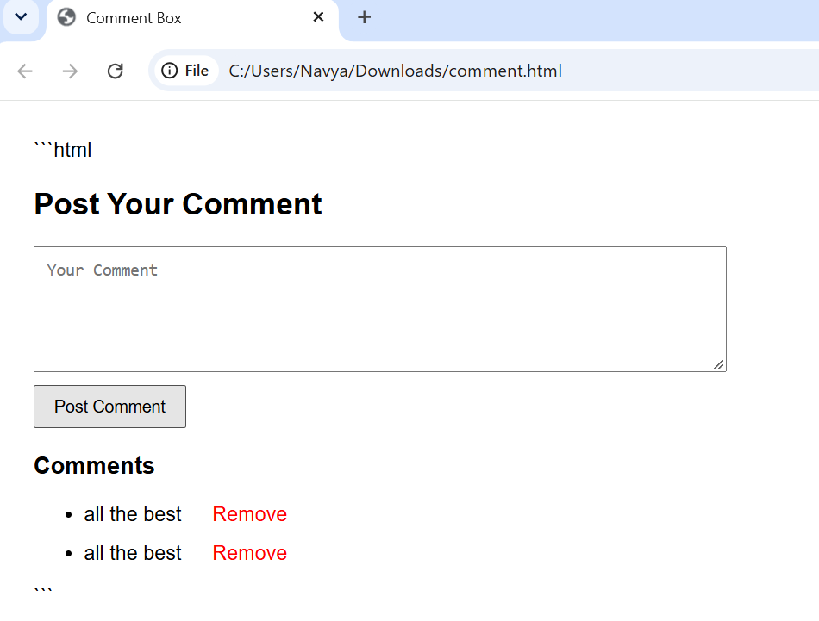

2. Simple Calculator Using AngularJS
Code:
<!DOCTYPE html>
<html lang="en" ng-app="CalculatorApp">
<head>
<meta charset="UTF-8">
<meta name="viewport" content="width=device-width, initial-scale=1.0">
<title>Simple Calculator</title>

<script src="https://ajax.googleapis.com/ajax/libs/angularjs/1.8.2/angular.min.js"></script>

<style>
body {
font-family: Arial, sans-serif;
margin: 40px;
}

.calculator {
max-width: 350px;
padding: 20px;
border: 1px solid #ccc;
border-radius: 8px;
}

input, select {
width: 100%;
padding: 10px;
margin: 8px 0;
box-sizing: border-box;
}

.result {
font-size: 20px;
color: green;
font-weight: bold;
}
</style>
</head>

<body ng-controller="CalculatorController">

<div class="calculator">
<h2>Simple Calculator</h2>

<label>Number 1:</label>
<input type="number" ng-model="a">

<label>Number 2:</label>
<input type="number" ng-model="b">

<label>Operator:</label>
<select ng-model="operator">
<option value="+">Addition (+)</option>
<option value="-">Subtraction (-)</option>
<option value="*">Multiplication (*)</option>
<option value="/">Division (/)</option>
</select>

<p class="result">
Result: {{ result() }}
</p>
</div>

<script>
angular.module("CalculatorApp", [])
.controller("CalculatorController", function($scope) {

$scope.a = 10;
$scope.b = 5;
$scope.operator = "+";

$scope.result = function() {
var a = Number($scope.a);
var b = Number($scope.b);

if ($scope.operator == "+") {
return a + b;
}

if ($scope.operator == "-") {
return a - b;
}

if ($scope.operator == "*") {
return a * b;
}

if ($scope.operator == "/") {
if (b === 0) {
return "Cannot divide by zero";
}
return a / b;
}
};

});
</script>

</body>
</html>
Output:
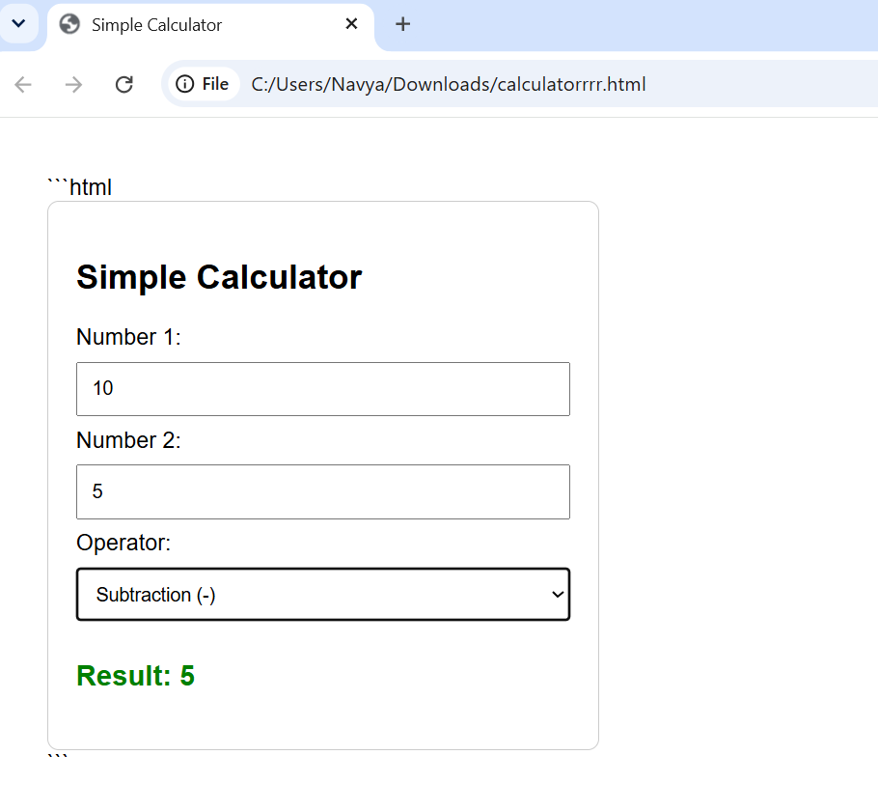

3. Simple To-Do List Using AngularJS
Code:
<!DOCTYPE html>
<html lang="en" ng-app="todoApp">
<head>
<meta charset="UTF-8">
<meta name="viewport" content="width=device-width, initial-scale=1.0">
<title>Simple To-Do List</title>

<script src="https://ajax.googleapis.com/ajax/libs/angularjs/1.8.2/angular.min.js"></script>

<style>
body {
font-family: Arial, sans-serif;
margin: 40px;
}

.todo {
max-width: 400px;
padding: 20px;
border: 1px solid #ccc;
border-radius: 8px;
}

input {
padding: 10px;
width: 65%;
}

button {
padding: 10px;
background: #0874df;
color: white;
border: none;
cursor: pointer;
}

li {
margin: 12px 0;
}
</style>
</head>

<body ng-controller="todoController">

<div class="todo">
<h2>My To-Do List</h2>

<input type="text" ng-model="title"
placeholder="Enter a task">

<button ng-click="add()">Add</button>

<ul>
<li ng-repeat="t in tasks track by $index">
{{ t }}
</li>
</ul>
</div>

<script>
angular.module("todoApp", [])
.controller("todoController", function($scope) {

$scope.tasks = [];

$scope.add = function() {
if ($scope.title && $scope.title.trim() !== "") {
$scope.tasks.push($scope.title);
$scope.title = "";
}
};

});
</script>

</body>
</html>
Output:


